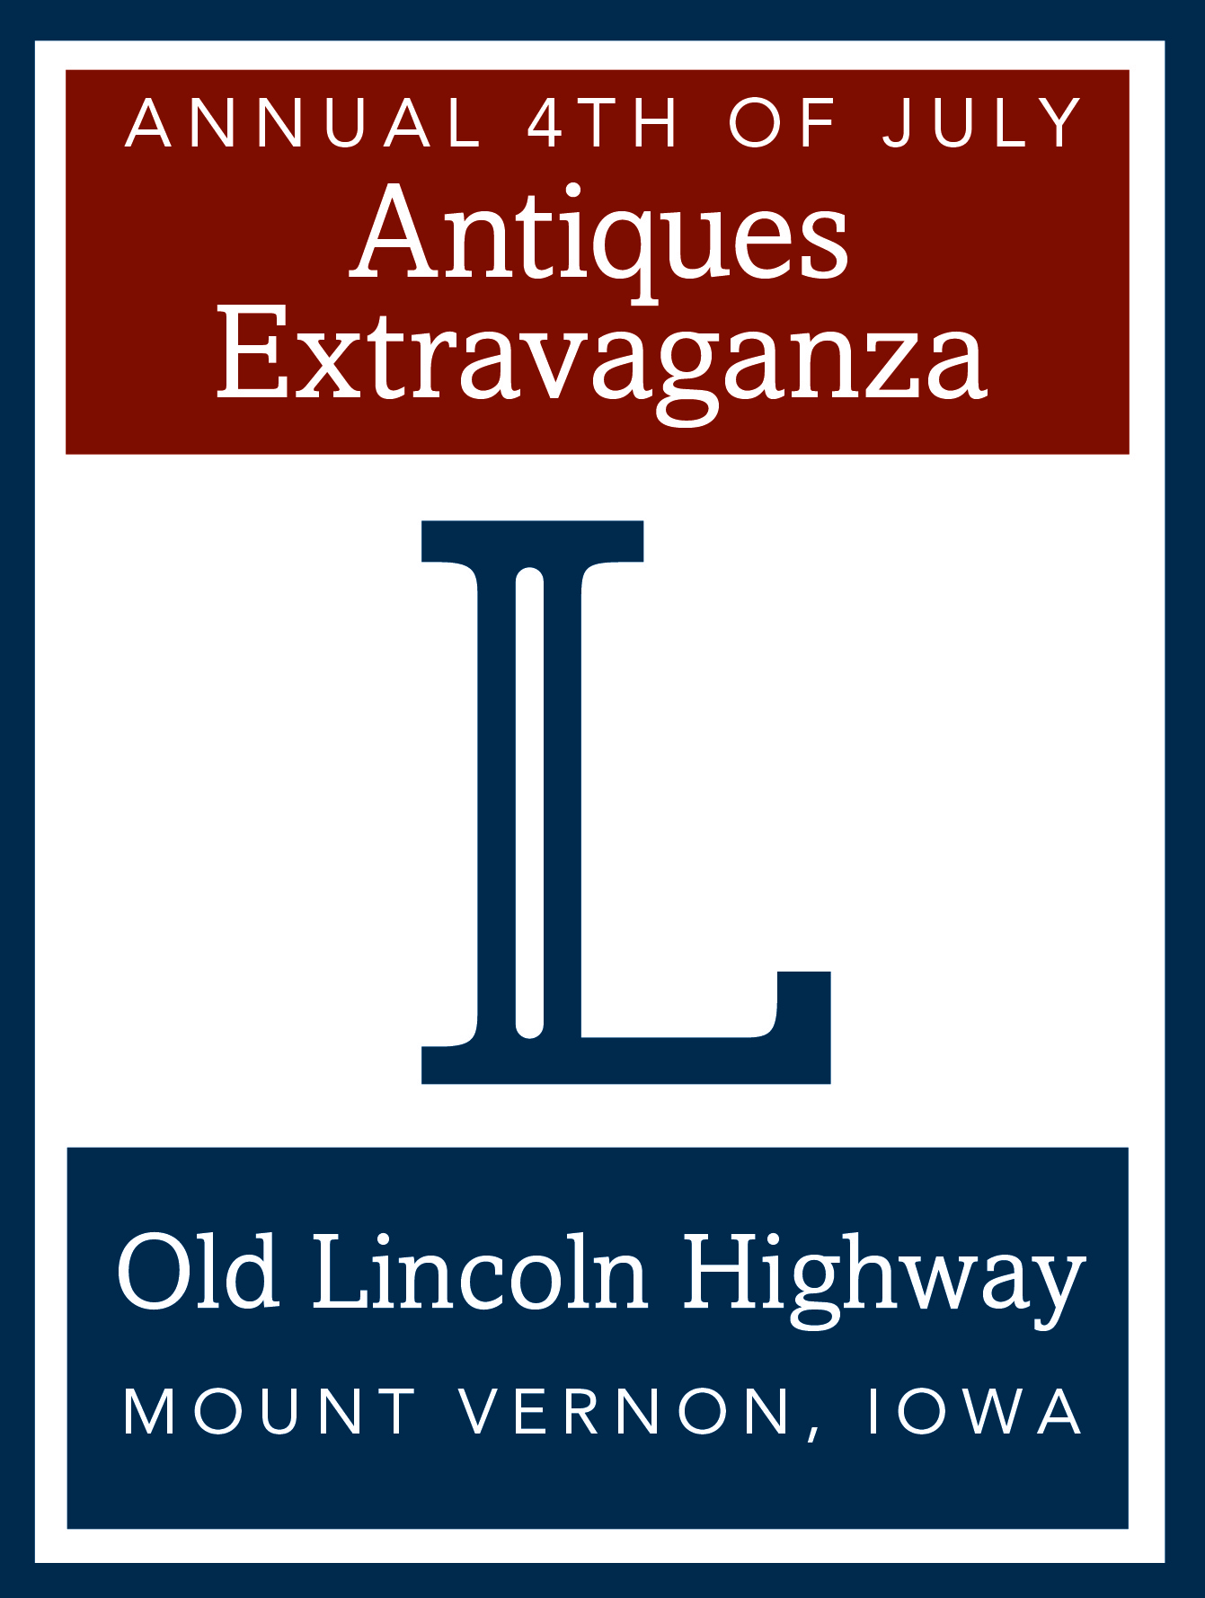 Historic Uptown Mount Vernon, Iowa presents the: 

Annual 4th of July
Lincoln Highway Antiques Extravaganza

The Annual 4th of July Lincoln Highway Antique Extravaganza (LHAE) has been well established in our community since 1989 and is surrounded by antique shops, specialty shops and cafes.
The open-air show is located “Uptown” on Main Street (1st St) and offers paved-surface booths only.
Rain or Shine / Free parking / Free admission / On site Volunteers

Promoter: Mount Vernon - Lisbon Community Development Group
- for a downloadable contract visit www.visitmvl.com
- you can call 319-210-9935 director@visitmvl.com or 319 310-2896 marye1840@gmail.com

Exhibitor contract Monday, July 4th 2016

Name, Last: ______________________________First: _______________________________Middle Initial: _______
Shop or Business Name: _____________________________________ Tax ID No.____________________________
Address: ____________________________________City: ______________________State: ______Zip: __________
Home phone: ___________________________ Cell phone: ______________________________________________
Email: ________________________________________Website: _________________________________________
Any special requests due to a health related issue? ie: need a volunteer_______________________________________
Iowa Sales Tax temporary permit available on day of show.

All booths are on paved surfaces in Uptown Mount Vernon.

Booths are: 10’ deep by 12’wide
See attached diagram for booth descriptions (next page).
Exhibitors may park a vehicle directly behind their booths.

Number of booths @ $75 each: _____________ Total Cost: _________________

Your timely return of this contract & payment is appreciated, in order to layout booths per block.
* Please make a copy of this page, for your reference, before returning to promoter.

Make checks payable to: CDG/LHAE, Mail to: PO BOX 31, Mount Vernon, IA 52314.

Read the Rules & Regulations attached.
The Undersigned agrees to all rules and regulations as stated in this contract:

Signed: ______________________________________ Date: _______________________

Booth Descriptions

Annual 4th of July Lincoln Highway Antique Extravaganza
All booths are on paved surfaces and face the shops and cafes. Booths are: 10’ deep by 12’wide (see diagram for booth descriptions below. Exhibitors may park a vehicle directly behind their booths.
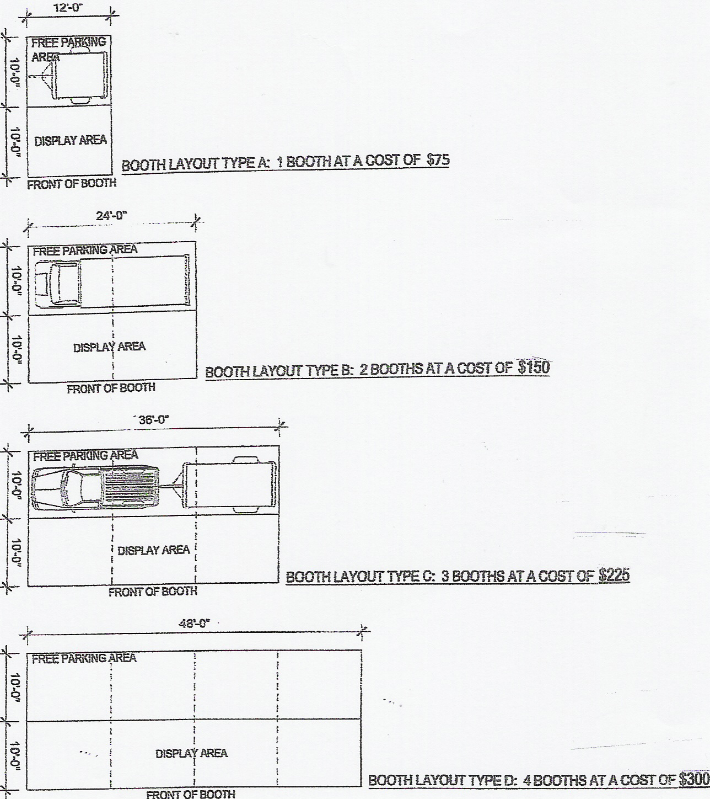

Site Map

Annual 4th of July Lincoln Highway Antique Extravaganza

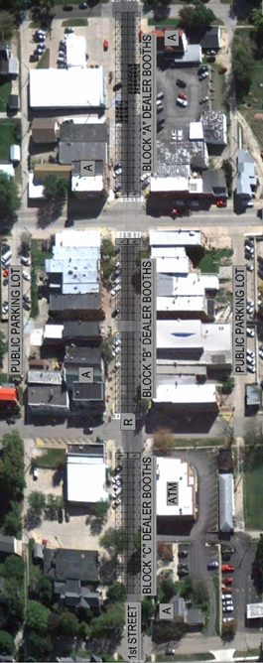
RULES AND REGULATIONS

Annual 4th of July Lincoln Highway Antique Extravaganza
Promoter: Mount Vernon-Lisbon Community Development Group

*This Antique Show welcomes dealers in antiques, vintage, architectural & agricultural salvage, industrial, primitives, repurposed and retro. All inventories must be clearly priced and all items must be appropriate for a family crowd.

*Applications are due on or before April 30, 2016. Applications that arrive after April 30 will be considered only at the discretion of the LHAE committee.

*Dealers will be asked to “cue up” their vehicles in a staging area while the street (aka festival grounds) are being marked and set-up. No dealer should expect admittance to the festival grounds prior to 4:00 p.m. on July 3rd. The staging area (2nd Avenue North) will be staffed as early as 2:30 p.m. to accommodate early arrivals. Staging instructions will be provided at the information tent upon arrival.

*No subletting of booths allowed.

*Night time security will be provided from 9:00pm July ^{3rd} until 6:00am July ^{4th}.

*CDG/LHAE is not responsible for any loss or theft of Exhibitor’s merchandise or equipment during any period of the show or during set-up and tear down. CDG/LHAE of Mount Vernon, IA, the sponsor, shall not be liable for any damage or claim.

*Exhibitors are to comply with all applicable local, federal, and sales tax and other laws relating to the sale of goods or services, and to obtain, pay for, and display all necessary licenses and permits and to pay all taxes and levies insofar as the Exhibitor’s own participation in the show is concerned. Mount Vernon has a 6% sales tax rate with an additional 1% Local Option Sales Tax for a total of 7% tax to be collected. Temporary permit forms from the State of Iowa are available from CDG. Vendors are responsible for submitting them to the state.

*The undersigned exhibitor hereby applies for exhibition space at the above named show and encloses payment herein. CDG/LHAE, its workers, agents and employees as well as the City of Mount Vernon, its workers, agents and employees shall not be liable for property damage or personal injury to Exhibitor, its agents or employees, which may occur on or about any part of the subject premises, regardless of how such injury or damage may have occurred. Exhibitor waives any claim against CDG/LHAE, the sponsor, or the City of Mount Vernon, IA and assumes all liability for loss or damage to Exhibitor’s property entrusted to the premises. Exhibitor shall hold CDG/LHAE, the sponsor, as well as the City of Mount Vernon, IA harmless and shall indemnify CDG/LHAE, the sponsor, the City of Mount Vernon, IA against all liability or expense arising out of injury or damage to any person or property, together with all cost in connection with the defense thereto, including attorney’s fees.

*The above-mentioned parties will not be held responsible if show is canceled for any reason. Be prepared for inclement weather, no refunds provided.
DEALER SET-UP INFORMATION

Annual 4th of July Lincoln Highway Antique Extravaganza
Promoter: Mount Vernon-Lisbon Community Development Group

*Exhibitors are required to register upon arrival at the show info tent. Info tent is located at the intersection of 1st St. & 2nd Ave. (corner by Mount Vernon Bank, see map – back of page 2). Staging instructions will be provided at the information tent. Dealers are asked to check in at the information tent before reporting to the staging area.

*Exhibitors will be responsible for supplying their own tables, tents and / or weatherization.

*Exhibitors with tents may only secure tents by weights or tied to their vehicle. No nails, spikes or pins will be allowed into the street surface.

*Exhibitors will be expected to keep their merchandise inside the space that they’ve been assigned, dealer merchandise should not “spill over” onto public spaces and sidewalks. This is to allow emergency vehicles immediate access if needed.

*Exhibitors may park vehicle / vehicles directly behind their booths, depending on how many booths you rent. That vehicle(s) will have to remain there for the duration of show, because it will be blocked in. Any vehicle that needs to come and go needs to vacate after set up. See diagram for booth or multiple booths and what size vehicle they will accommodate.

*Exhibitor’s booths must be open during the entire show hours July 4th 7:00am - 4:00pm, and may not start packing-up until 4:00pm on day of show.

*Exhibitors will not be allowed to set-up until released from the staging area by the volunteer block captain for their assigned block (approximately 4:30pm).

*Exhibitors will need to be completely vacated from the street by 6:00pm, on July 4, when the street re-opens.

*Volunteers will be available to assist with unloading and loading at the Exhibitor’s own risk. These volunteers are working as a fundraiser for their baseball team and will gratefully accept gratuities.

*Volunteers will be available: July 3rd from 4:00pm until 7:00pm and on July 4th – 6:00am to 6:00pm.

*The show is held on public streets so there may be walking traffic as you set up, you are welcome to sell your items during that time.

*See Contract, Booth plans, Map and Rules & Regulations for more specific information.

*Please check our website www.visitmvl.com for lodging information.

