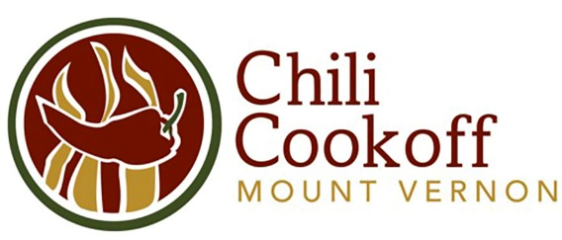
17th Annual Chili Cookoff Application
Uptown Mount Vernon
Saturday, October 14, 2023
Cash Prizes for Winners!
For further information please contact Sue Margheim at msmargheim@msn.com or Joe Jennison at 319-210-9935 and director@visitmvl.com

Today’s Date:

Chili Team Name:

Team Captain:

Address:

City/State/Zip:

E-mail: Cell Phone:

Canopy Tent (Required): Bringing My Own Tent I Need to Rent a Tent from CCDG

Space is limited, please register your team early!
Application Fee: $25
Receive a Gary’s Foods gift card!

Chili Cookoff Fees:
$25 Entry Fee (early bird entries returned)
I'm cooking with propane –Free
I need electricity to cook --$25
I need to Rent a 10x10 canopy tent --$75 (Contact Sue if financial assistance is needed)
Total entry fee - Make checks payable to CCDG

Checks may be made payable to CCDG. Complete applications with fee can be mailed to:
Sue Margheim
Attn: Chili Cookoff
P.O. Box 31
Mount Vernon. IA 52314

Release
Entrants and participants, by execution of this Entry Form, release and discharge the State of Iowa, Linn County, the City of Mount Vernon, the Mount Vernon-Lisbon Community Charitable Development Group Chili Cookoff and anyone else connected to the management or presentation of this contest from any and all known and unknown damages, injuries, losses and/or claims from any cause whatsoever that may be suffered by any entrant or participant to their person or property. By completing and submitting this form, the entire team agrees to follow the rules and guidelines of this contest.

Signature: Date:

Chili Cookoff Guidelines:
Thanks for taking part in the 17th Annual Mount Vernon Chili Cookoff on October 14th! These are a few guidelines to help make the cookoff a success for teams and for the public.
Please note that food safety is critical! Use sanitary practices that meet health code requirements; keep chili hot and dairy items must be kept cool. The Linn County Department of Health will inspect each team’s set up.
- All ingredients must be prepped and cooked on-site under a 10’ x 10’ canopy tent per Linn County Health Department.
- Each team must make a minimum of 5 gallons of chili.
- Cooking on a camp stove, propane burner, turkey fryer is strongly recommended.
- Limited electricity is available; power strips are not allowed.
You’ll need to bring:
- Heat source for cooking
- Extension cord (no power strips) if you’re using electricity
- Ingredients to make your chili
- Utensils for preparing and serving your chili
- Hats or hair nets
- Hot and cold food thermometers
- Canopy tent, 10’ x 10’ and leg weights are required (limited supply available for rent)
- Tablecloth & decorations for your canopy tent, costumes for you and your team (optional)
- Chairs, additional table for your own use (optional)
Provided to you:
- One 8’ table (for preparing and serving your chili)
- Handwashing station with catch bucket
- Sanitizing solution in a spray bottle
- Paper towels
- Waste buckets for compostables, recyclables, garbage
- Gloves, serving cups, napkins, spoons for serving your chili
- Common rinsing station for utensils (there will NOT be a place to wash dishes so please plan accordingly)
Timeline:
- 11 a.m. – Teams can arrive and begin setup and cooking
- 2:00 p.m. – Bags Tournament registration begins
- 4 p.m. – Public tasting begins
- 6:45 p.m. – Announcement of the winners
Judging:
Separate judging will be decided by a panel of local judges AND a people's choice vote. Judging will take place throughout the public tasting portion and winners will be announced at 6:45pm. More information on judging criteria will be provided upon registration.

Finally, we are endeavoring to make this a waste-free event. All supplies provided by the Chili Cookoff committee can be recycled or composted. We ask you to participate by avoiding use of Styrofoam and other nonrecyclable, noncompostable trash as well.

